ADULT SLIPERS
***use ½” seam on the lining and ¼” seam on outer
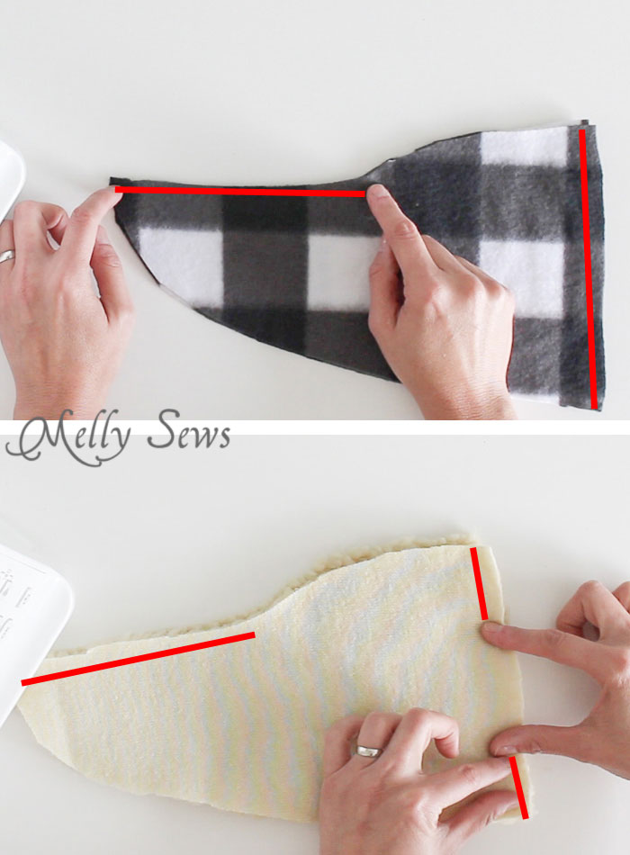
To resize the pattern, first either measure the length and width of the person’s foot, or use google to find a foot length chart; there are a lot out there. Then cut the pattern on the horizontal lines to lengthen the or shorten the slipper, and cut on the vertical lines to widen or narrow it.Spread pattern pieces apart to lengthen and widen, overlap to shorten and narrow. Then retrace the pattern on a new paper.
Cut 4 upper slippers from BOTH the lining and outer fabrics, making sure to mirror image them so that you have 2 right sides and 2 left sides of each. Cut 2 soles from BOTH the lining and outer fabrics, making sure to mirror image them so that you have a right foot and a left foot of each. Use the slip soles and cut two mirror soles.
Place the outer upper slippers right sides together, then stitch along the foot and heel (red lines below). Use a 1/4 inch seam. Make sure to backstitch the foot seam at the inner point. Repeat with other set of outer slippers.
Repeat this process with the lining, EXCEPT leave a hole in the heel of the lining for turning later.
Open up the upper slippers and pin them right sides together with the soles (with the grippy material sandwiching the upper piece and the sole on the outer fabrics), centering the upper seams at the center of the toe and heel. Repeat for all the lining and outer pieces, so that you have 4 slippers, and make sure there are 2 right feet and 2 left feet.
Stitch around the slippers, then turn the lining slippers right sides out. Match up the left foot of the right side out lining with the left foot of the wrong side out slipper, and do the same for the right feet.

Insert the lining into the slipper, then match and pin around the ankle. Repeat with the other slipper, then stitch around the ankle of each.
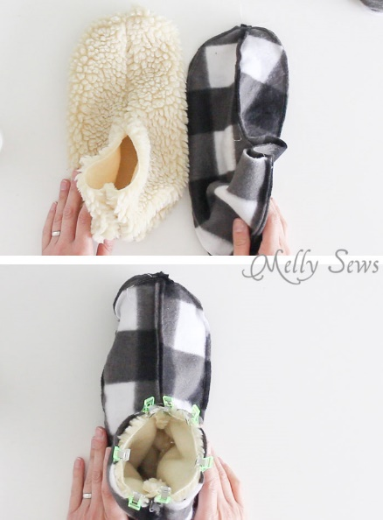
Turn each slipper right side out through the hole in the heel of the lining.
When they’re right side out, they’ll look like the image above, with conjoined slippers. Push the lining into the slipper.
Use a hand sewing needle and thread and a blind stitch to close up the hole in the lining of each and you’re done!
Turn the cuffs of the slippers down or up depending on how cold your ankles get.

