CRAMP KIT POCKET PATTERN INSTRUCTIONS
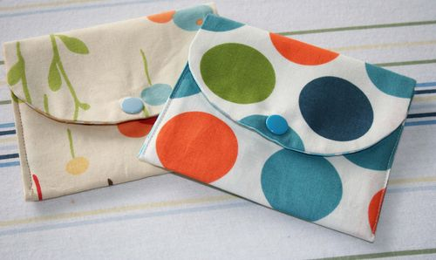
Use pattern to cut one piece from main fabric, one from the lining contrast fabric, and one from lightweight fusible interfacing if using cotton fabric (no interfacing needed for heavier fabric) If you are using the lighter cotton fabric, affix the interfacing to the wrong side of the main fabric by ironing it on.
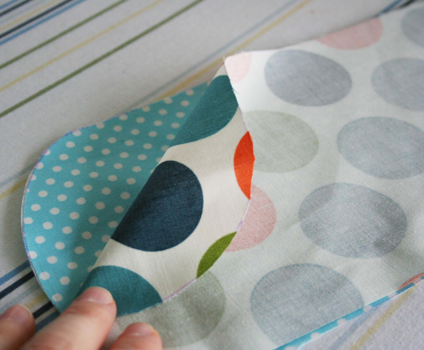
Lay your main fabric face down on your lining fabric stacked so that the main and lining fabric right sides together. Sew all the way around the outside edge using ¼ inch seam leaving a 2 inch opening on one side for turning. Clip corners and turns being careful to not cut into your seams

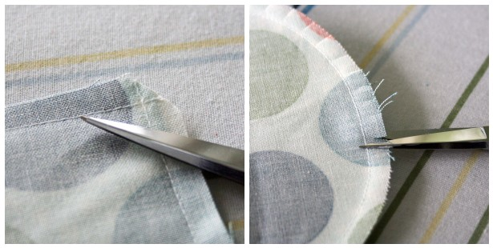
Turn the pouch right side out and use a knitting needle or something similar to make sure all the corner and top curve are turned all the way out. Lay the pouch flat and iron it, making sure to fold in the seam allowance at the opening so the unstitched fabric is tucked inside the pouch. You will close the opening when you edge stitch the outside of the pouch.
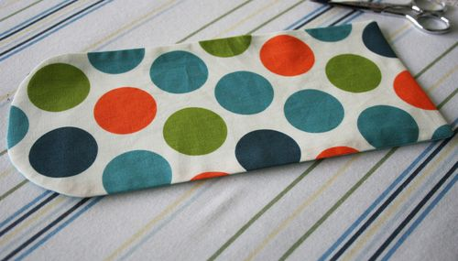
Fold the pouch as in the picture below or also see the first picture at the beginning of instructions. Edge stitch up each side of the pouch and around the top curve. With it open like below.
THANK YOU for sewing and we will attach the snap with our handy dandy machine.
