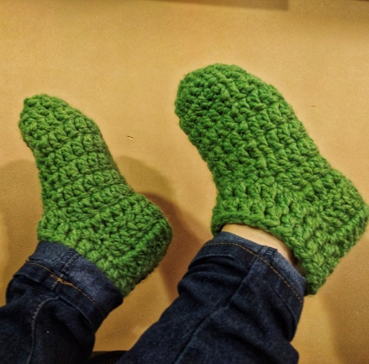
CROCHET CHUNKY YARN SLIPPERS
Yarn: Small size: One skein of Lions Brand Wool-Ease Thick & Quick super bulky yarn, (6). This yarn is super soft and squishy as it is a wool blend. 20% wool and 80% acrylic.
Medium and Large sizes need two skeins of Lions Brand Wool-Ease Thick & Quick

Notions:
Hook: size 5.75 mm. US – J /10 (some J hooks are 6mm and that should be ok, Tapestry needle, scissors.
Gauge: 9 DC – just under 5 rows of DC = 4” (10 cm)
Abbreviations (uses US conventions)
- Ch = chain
- st = stitch
- dc = double crochet
- sc = single crochet
- sl st = slip stitch

Warmest Feet Ever Slipper Socks for Small

Small: (for sizes 5-6)
Finished Slipper Sock Size: Foot length 8.5“/ 9-10” in circumference.
Instructions:
Please note that the Ch 2 worked at the beginning of a Round does not count as a stitch. Do not turn at the end of each round as it is worked in the round.

Chain 3 and join to make a small ring, or make a Magic Loop to start.
Round 1:ch 2 and make 10 DC in the ring, join to top of first DC with a sl st,
Round 2: Ch2, 2 DC in each stitch around, join to top of first DC, (20 DC)
Round 3-6: Ch2, DC in each stitch around, join to top of first DC, (20 DC)
Round 7: Ch2, DC in 15 stitches, next HDC in next st, SC in the next 3 stitches, HDC in last st, join to top of first DC, (20 DC)
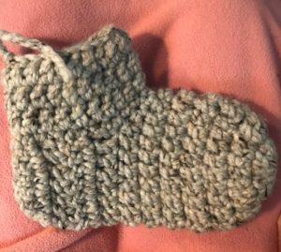
Round 8: Ch2, DC in 15 stitches, (15 DC)
Round 9 and 10: Ch2, turn, DC in next 15 stitches, (15 DC)
Round 11: Ch2, turn, DC in next 6 stitches, DC3 together, DC in next 6 stitches (13 DC)
Do not fasten off.
Slip stitch to the top of the 1st stitch of this row to create the heel.
Now turn the slipper so the toe is facing away from you.

Begin to work up the ankle.
Round 1: Ch 1 and sc into the ends of each row and around the front of the foot, then up the other side, sl st into the top of the ch1 (20 st approx)
Round 2: Ch2, DC in each stitch around, join to top of first DC.
Round 3: Ch2, DC in each stitch around, join to top of first DC.
Round 4: Ch2, DC in each stitch around, join to top of first DC.
Fasten off, weave in ends.
Turn inside out and sew up the heel seam.

